Login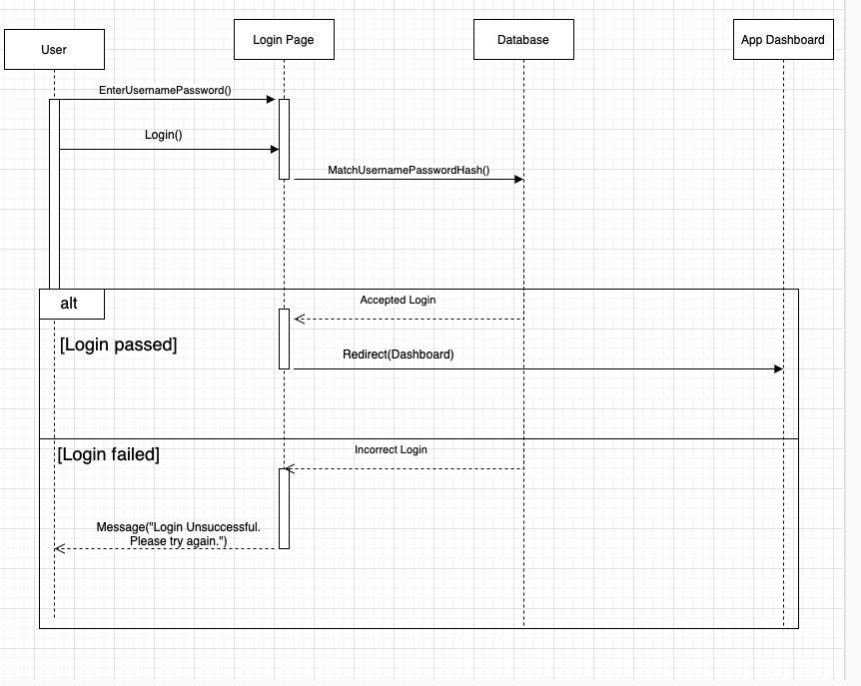

Create Group Session

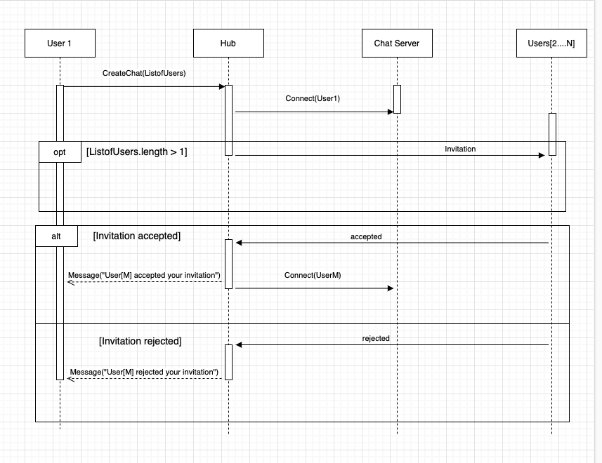

Save Drawings

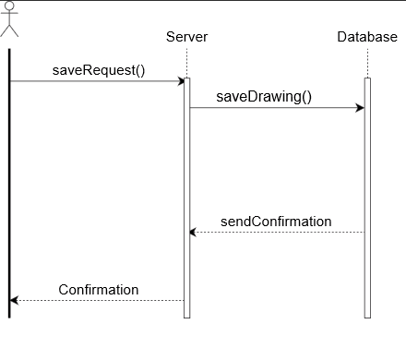

Retrieve Drawings

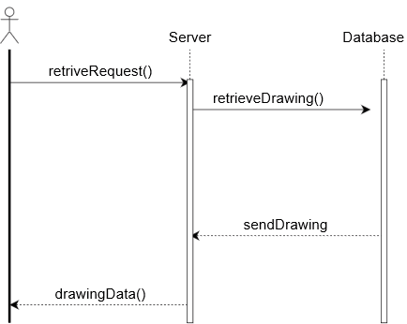

Draw Graphics

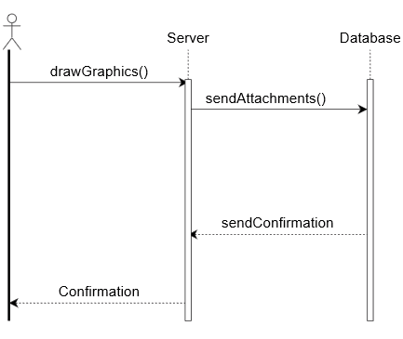

EDIT MESSAGE:

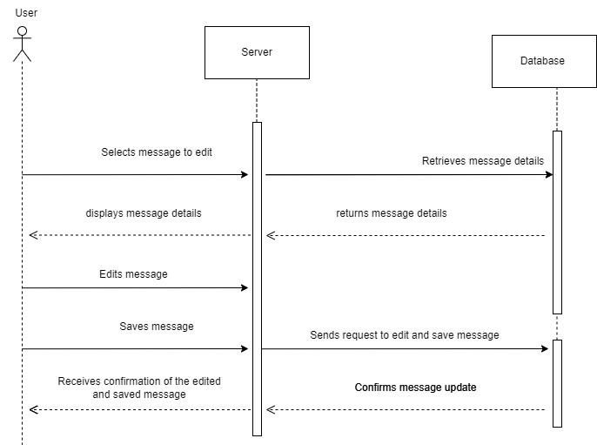

SEND MESSAGE:

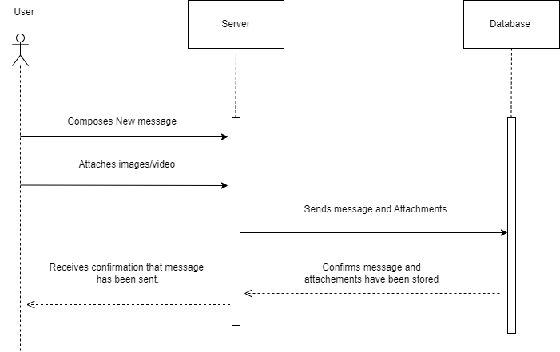

SUGGESTION:

* Save, retrieve and draw graphics diagrams convey processes effectively but could use some activation boxes and proper arrows to represent “Reply message symbol”. I have tried to include my suggestions on the images below . Feel free to incorporate / disregard my suggestions.

